- Install nginx and run nginx on port number 81.
Steps:
1.login in AWS console ->search for EC2 -> And click on Instances -> Launch instance
2.Give a name or tag and click on amazon Linux AWS -> select architecture 64-bit(*84)
3.select instance type t3 micro and create a new pair key -> select no. of instances as 1
3.click on launch instance -> instance launched successfully.
4.click on running instances and select we created or launched instance
5.click on connect and then select public IP -> open Git bash and set key permissions
Steps for install nginx:
1.install nginx using yum command
2.check the status that in inactive state
3.use the start command to start the nginx
4.nginx started, go to browser check it with public ip and port no 80 .output comes,

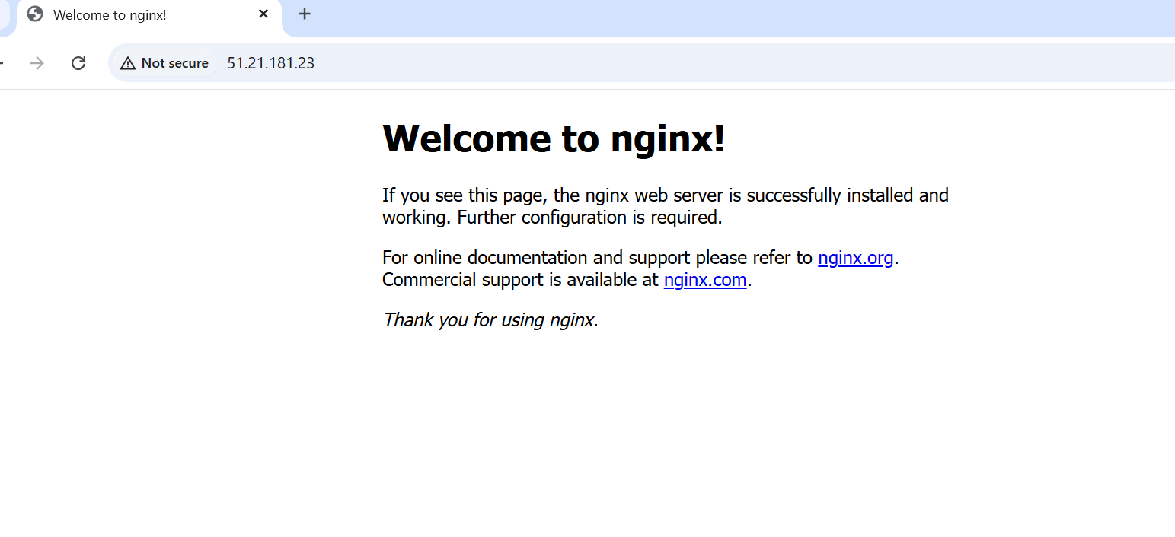
Go to AWS console ->open ec2 ->security group -> click on edit inbound rules and add rules like add port numbers.

5.to change the port number 80 to 81, then go to deployment location
6.change the port number 80 to 81 and save.
7.restrt and check the status, refresh the browser using port no 81
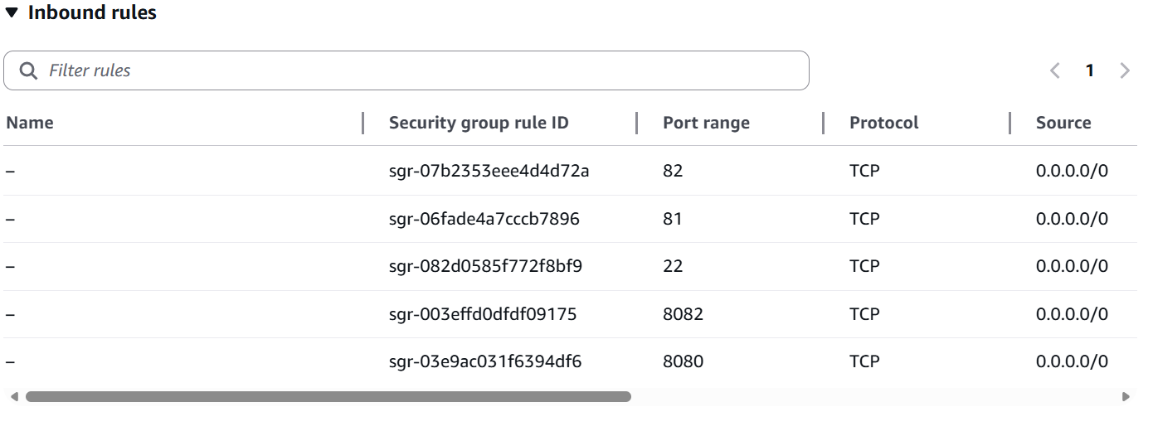

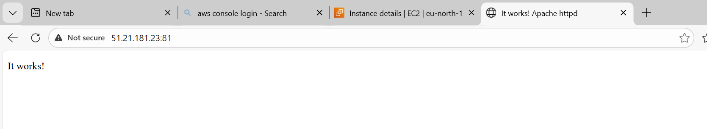

2.Deploy a sample index.html file on nginx.
1.after installing nginx,go to index.html file
2.change the static page as our sample index.
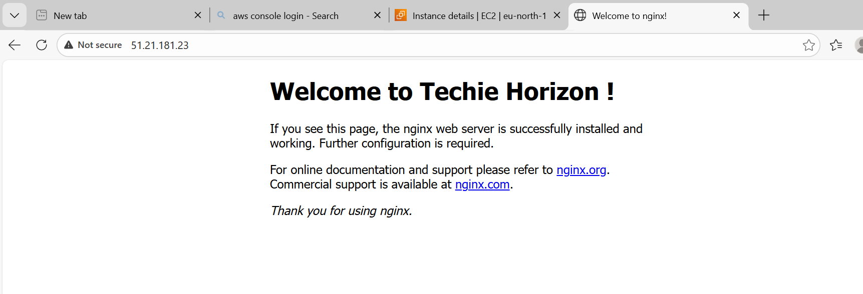

3.Install Apache and run Apache on port number 82
Steps for install Apache:
1.install Apache using yum command
2.check the status that in inactive state
3.use the start command to start the Apache
4.apache started, go to browser check it with public ip and port no 80 output comes,
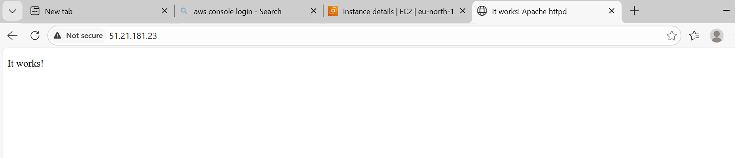
Go to AWS console ->open ec2 ->security group -> click on edit inbound rules and add rules like add port numbers.


5.to change the port number 80 to 82, then go to deployment location
6.change the port number 80 to 82 and save.
7.restrt and check the status, refresh the browser using port no 82

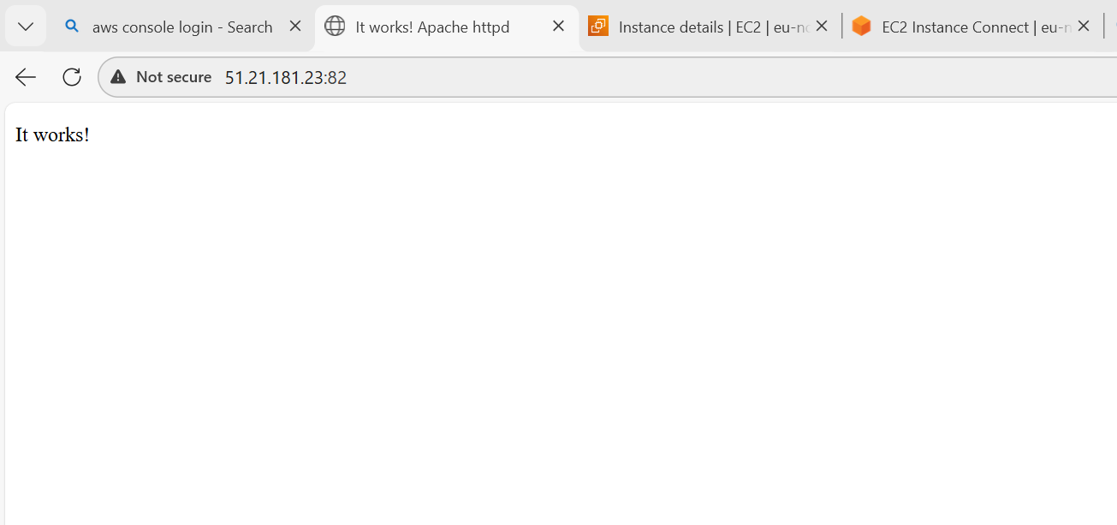

4.Deploy a sample index.html file on Apache.
1.after installing Apache, go to index.html file
2.change the static page as our sample index.

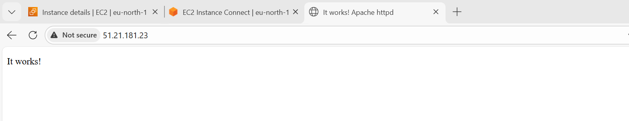
5.Install Apache tomcat on port number 8082
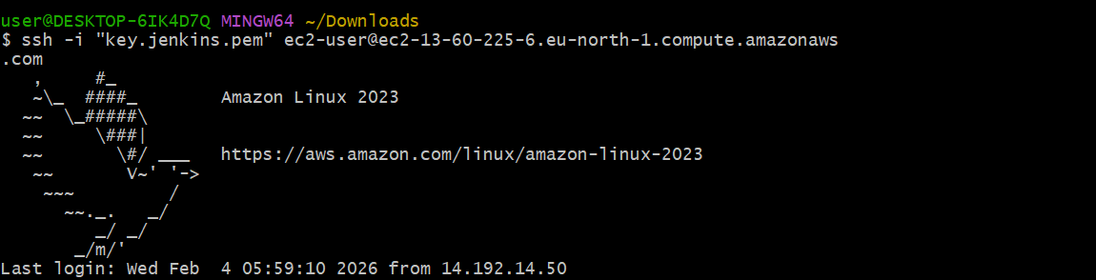
1.first we the java then Apache tomcat works
2.apache tomcat is installed using yum command then copy the Apache tomcat tar file link
3.we install the tomcat using Wget command
4.extract the tar file and Apache tomcat installed
5.then check it works using startup.sh
6. go to browser and enter public ip with port number 8080 it works
7.to change the port no 8080 to 8082 , then we make sure to change in server.xml file
8.then save it and start withstartup.sh command
9. go to browser and enter public ip with port number 8082 it works
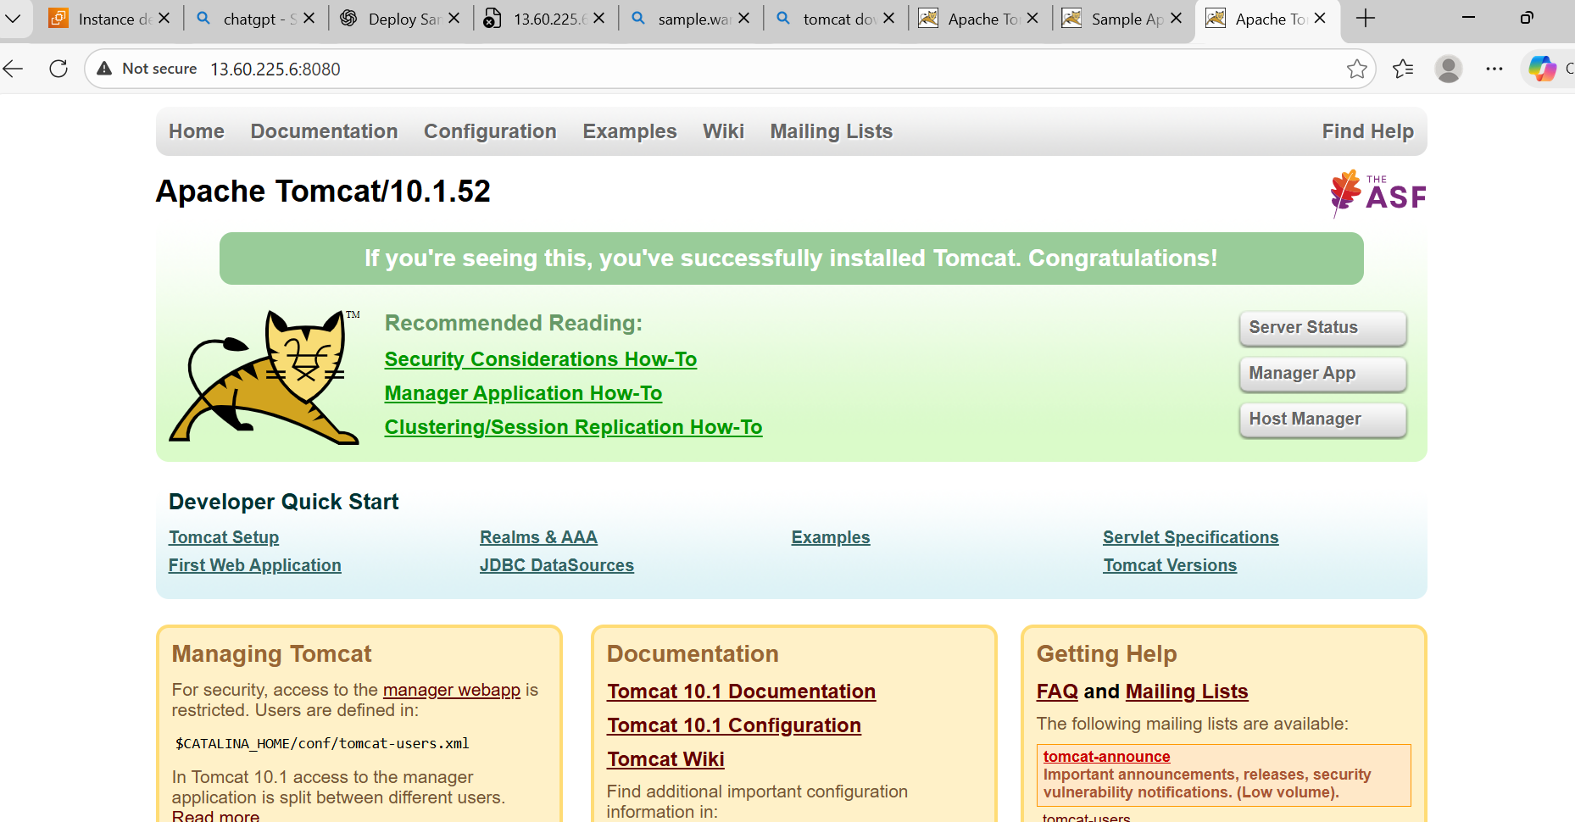
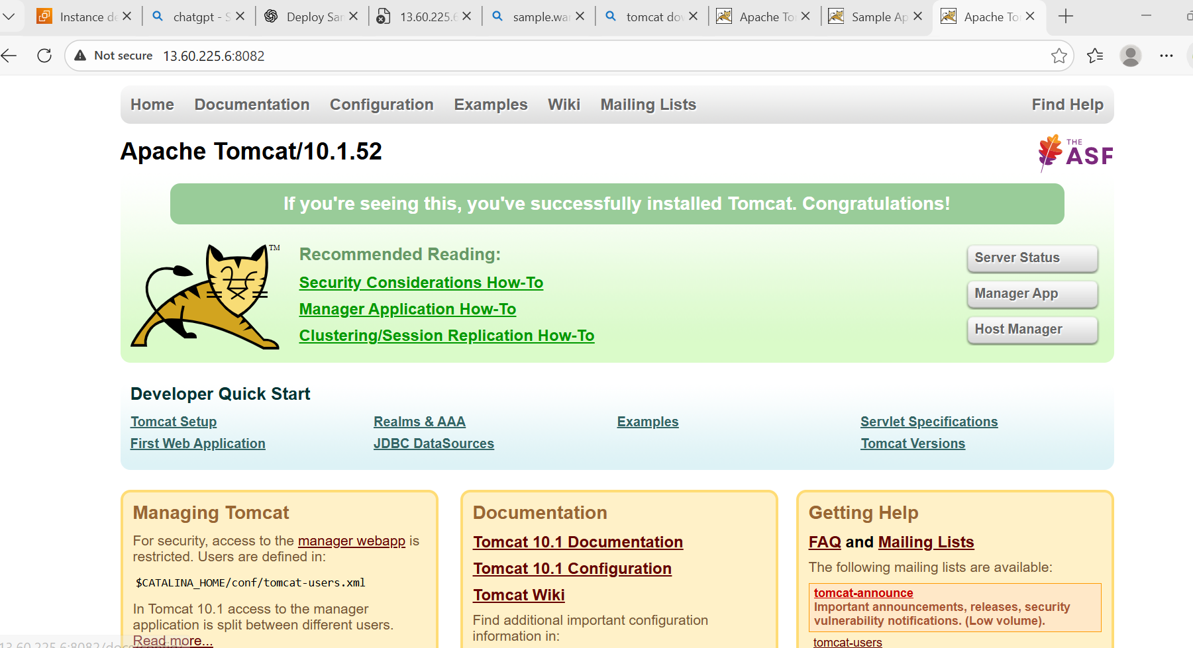
6.Deploy a sample app on webapps
1.we are currently connected to aws linux ser SSH in git bash terminal
2.tomcat is already installed and tomcat service is set up
3.then go to webapps directory
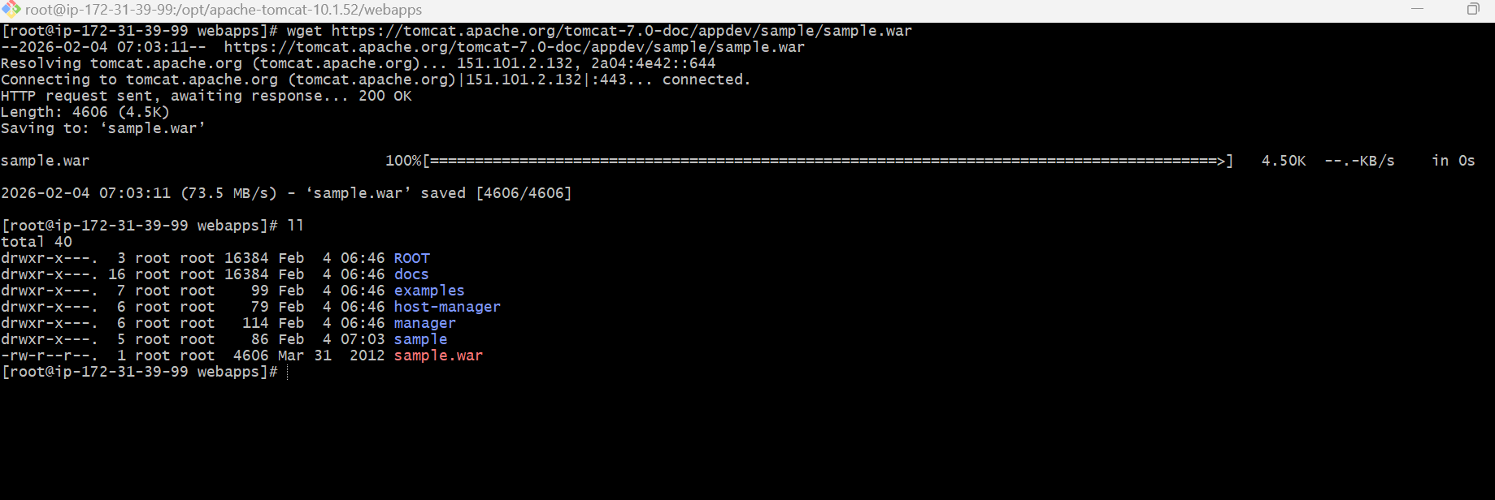
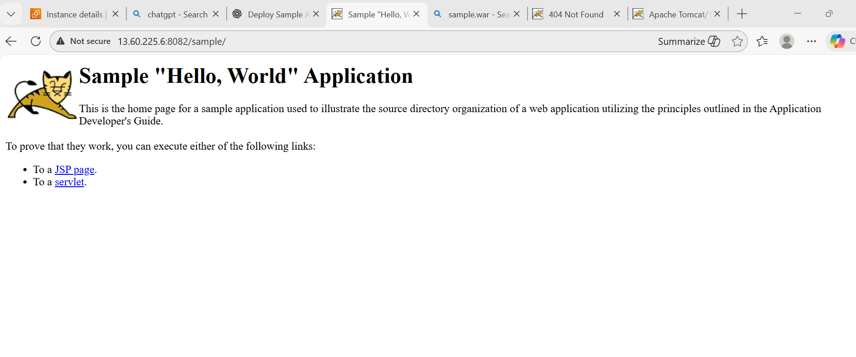
7.Create a tomcat. service file for tomcat.
1.we are currently connected to Aws Linux ser SSH in git bash terminal
2.tomcat is already installed and tomcat service is set up
3.create a tomcat user and create a service file
4.reload the system, start the tomcat service
5.enable the tomcat and last test on browser.
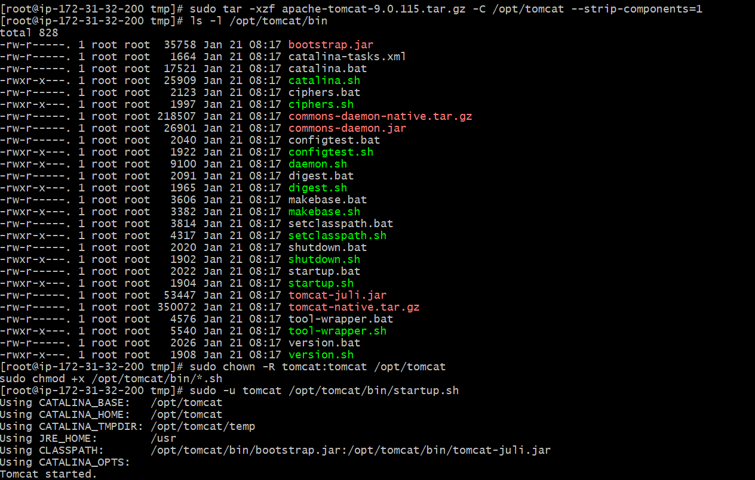
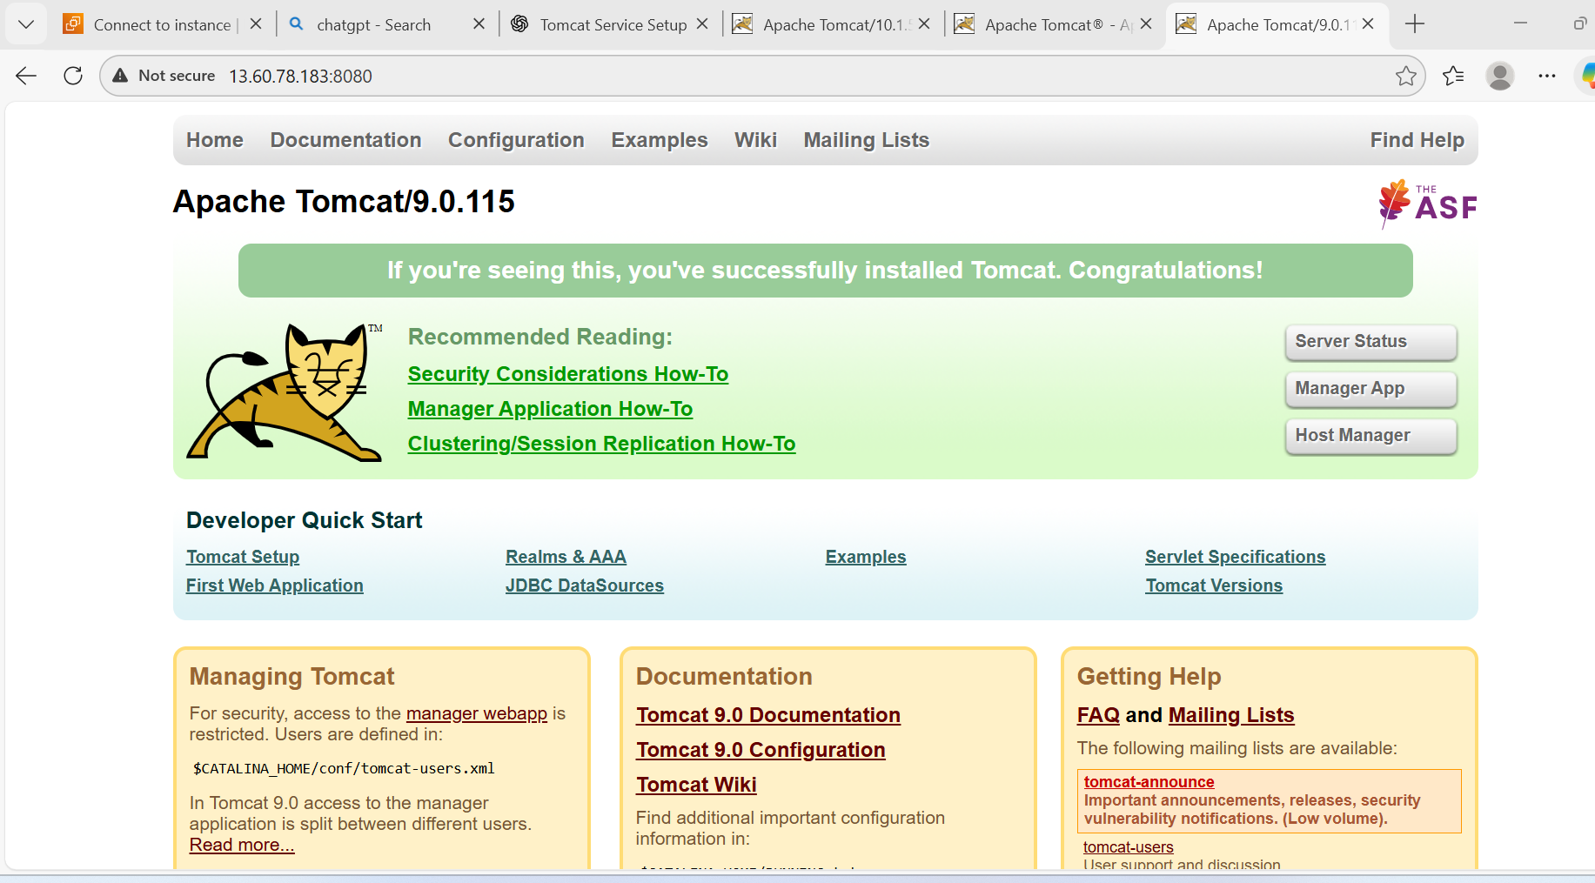
8.Configure HA Proxy server
